# Security tools results

## git secrets

Output from command git secrets --scan-history:

None

## cfn-guard

Output from command cfn-guard validate -r ../aws-guard-rules-registry/rules/aws -d ./

Failing rules:

1. Sample Lambda functions do not have VPC access enabled (LAMBDA_INSIDE_VPC)
2. Sample Lambda functions do not have reserved concurrency configured (LAMBDA_CONCURRENCY_CHECK)
3. Sample Lambda functions do not have DLQ configured (LAMBDA_DLQ_CHECK)
4. Two sample Lambda functions are allowed read-only access to the wildcard resources (IAM_POLICYDOCUMENT_NO_WILDCARD_RESOURCE). This is by design to allow inspection of any existing or new API Gateway instance in the account.

## cfn-lint

Output from commands:

* cfn-lint ./eda/template.yaml - nothing
* cfn-lint ./tools/template.yaml- nothing
* cfn-lint ./tools/api-account-inspector/template.yaml- nothing
* cfn-lint ./tools/api-definition-retriever/template.yaml- nothing
* cfn-lint ./tools/api-inspector/template.yaml- nothing
* cfn-lint ./tools/openapi-validator/template.yaml- nothing
* cfn-lint ./iac/api-builder-agent.yaml – “E1029 Found an embedded parameter "${AWS::Region}" outside of an "Fn::Sub" at Resources/ApiBuilderAgent/Properties/Instruction” iac/api-builder-agent.yaml:35:7” – expected as ${AWS::Region” is used in a model prompt (inline string)
* cfn-lint ./iac/api-expert-agent.yaml- nothing
* cfn-lint ./iac/api-inspector-agent.yaml - nothing
* cfn-lint ./iac/api-openapi-generator-agent.yaml - nothing
* cfn-lint ./iac/api-requirements-gatherer-agent.yaml - nothing
* cfn-lint ./iac/bedrock-flow.yaml - nothing
* cfn-lint ./iac/bedrock-kb-aos.yaml - nothing

## Semgrep

Output:

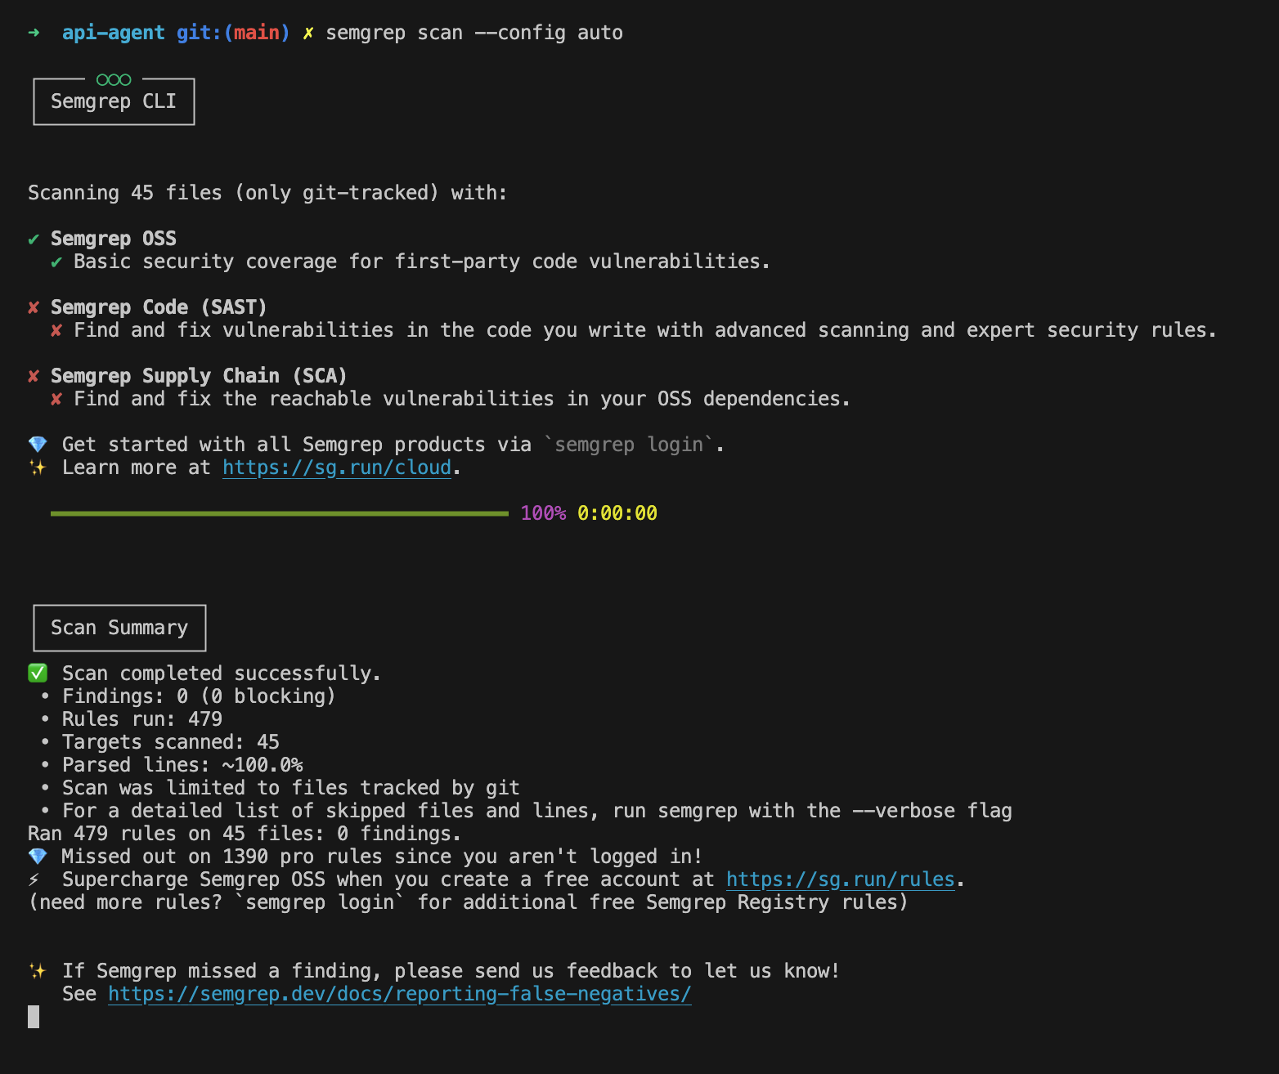

## npm-audit

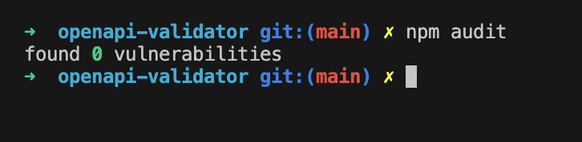

## bandit

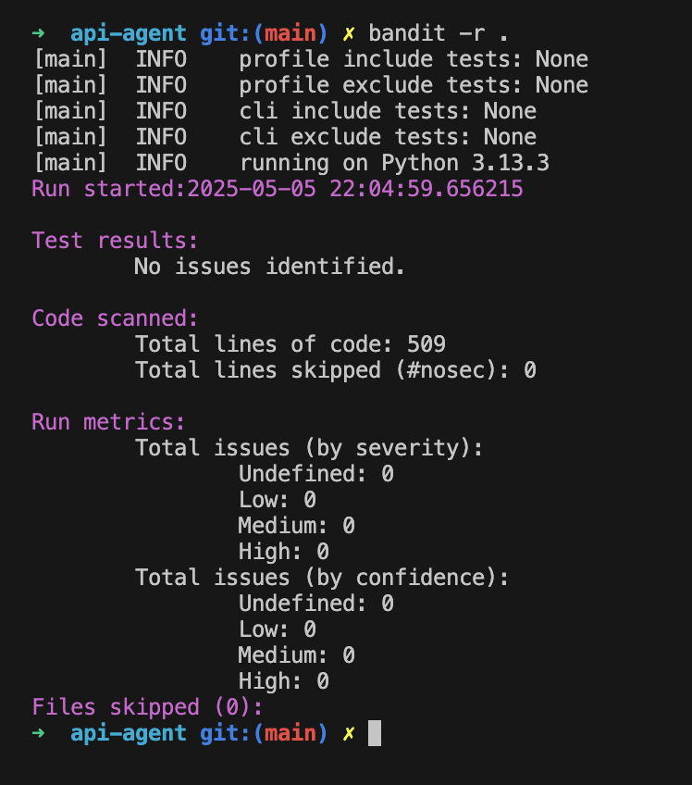

## dependency-check

